COP2373:Programming Concepts II
Programming Exercise 4
Anthony Farah
Introduction
This assignment explores the use of keyword arguments in Python, focusing on the **kwargs syntax as described in Section 4.8.2 of the textbook. In Python, '**kwargs' allows a function to accept any number of named (keyword) arguments, which are stored in a dictionary inside the function. The objective is to show how Python functions can handle flexible and dynamic sets of named parameters. The section uses examples executed in the IPython environment, displaying code and output together for clarity. Screenshots sequentially show the start of IPython, a function call using keyword arguments (where parameters are specified by name), the definition and use of a function that processes any number of named arguments using **kwargs, and a function that handles both positional arguments (using *args to collect values in a tuple) and named keyword arguments (using **kwargs for a dictionary). These examples clarify Python's method of argument unpacking, splitting input into positional or named arguments, the design of functions to accept customizable input, and the difference between named keyword arguments and traditional unnamed positional arguments. After the screenshots, a detailed analysis outlines the main advantages and disadvantages of using **kwargs in real-world programming, offering insight into situations where this feature is most effective and some challenges it can present.
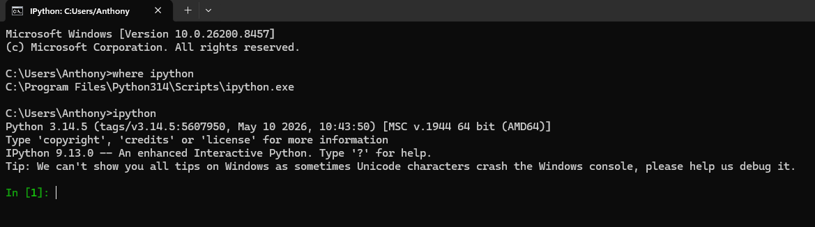
Screenshot 1: Opening the IPython environment. This screenshot shows the initial IPython prompt (In [1]:), confirming that the interactive Python shell is active and ready for executing the examples from Section 4.8.2.
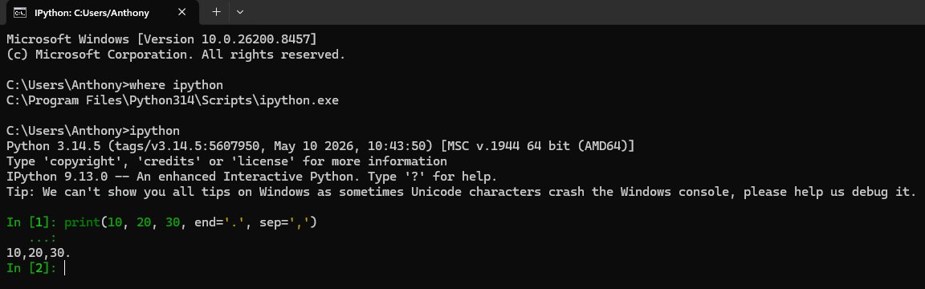
Screenshot 2: Executing a function call with keyword arguments. This screenshot displays the print(10, 20, 30, end='.', sep=',') statement and its output. The example demonstrates how keyword arguments (end and sep) modify the behavior of the built-in print function.
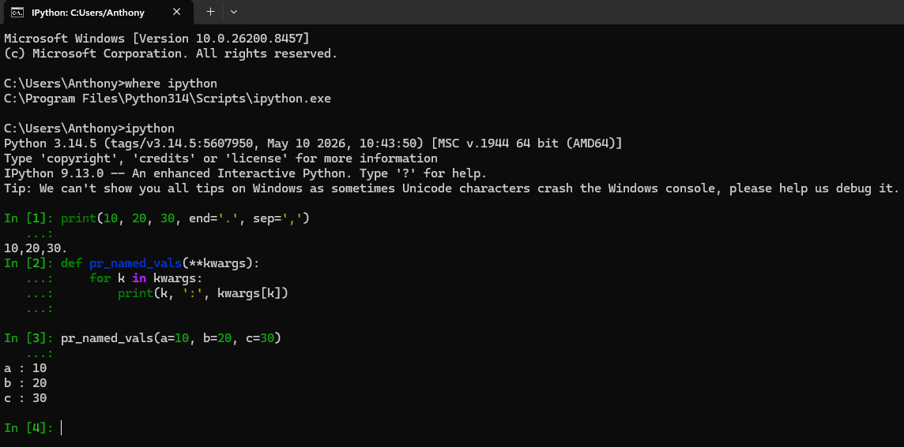
Screenshot 3: Defining and calling a function that uses **kwargs. This screenshot shows the definition of the pr_named_vals(**kwargs) function and its execution with named arguments (a=10, b=20, c=30). The output confirms that **kwargs collects the named arguments into a dictionary and allows the function to iterate through and print each key–value pair.
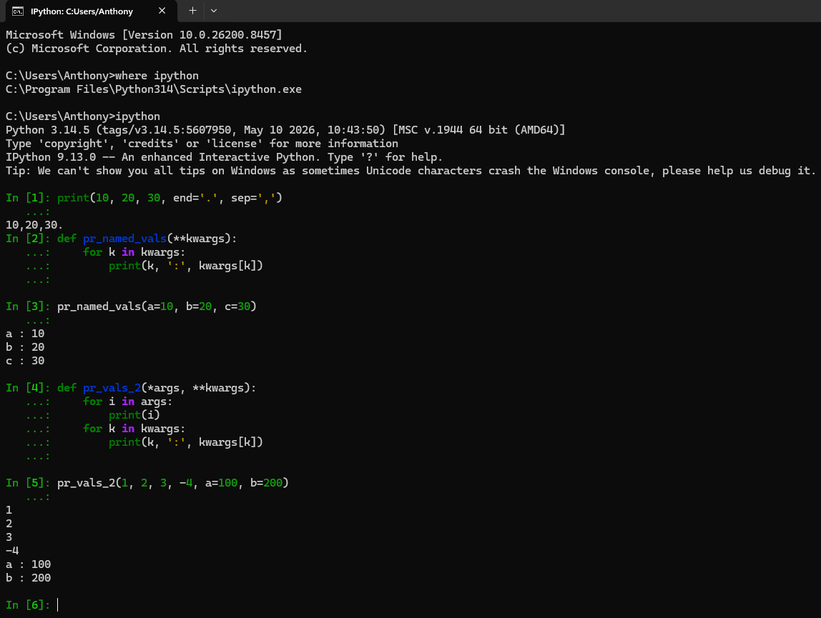
Screenshot 4: Using both *args and **kwargs in a single function. This screenshot includes the definition of pr_vals_2(*args, **kwargs) and its execution with a mix of positional arguments (1, 2, 3, -4) and keyword arguments (a=100, b=200). The output demonstrates how the function processes positional arguments first, followed by named arguments.
Advantages of **kwargs
- Enhanced flexibility in function design:
The use of **kwargs enables a function to accept any number of named arguments, including those not anticipated during initial development. This approach allows the function to adapt to diverse use cases without necessitating frequent modifications to its signature.
- Facilitates highly customizable behavior
Since **kwargs aggregates arguments into a dictionary, the function can interpret and respond to various parameter combinations. This capability is particularly valuable in configuration systems, APIs, and GUI frameworks, where optional settings often differ between calls.
- Enables backward compatibility in updates
In established codebases, adding new named parameters to a function typically risks breaking existing code. By employing **kwargs, developers can introduce new optional parameters without impacting prior function calls, thereby facilitating software evolution and maintenance.
- Integrates effectively with wrapper functions and decorators
**kwargs is essential when one function passes arguments to another, as in decorators or higher-order functions. It ensures that all named arguments are preserved and forwarded accurately, even if the wrapper function does not explicitly specify the arguments.
- Enhances readability for optional settings
While excessive use may reduce clarity, employing **kwargs for optional or infrequently used parameters can simplify the main function signature. Rather than enumerating numerous optional parameters, the function can accept them via **kwargs, thereby maintaining a streamlined interface.
Disadvantages of **kwargs
- Decreased clarity regarding expected arguments
When the function signature does not explicitly list parameter names, it becomes difficult for other programmers to determine which arguments the function is intended to accept. This limitation can hinder comprehension and correct usage without examining the internal implementation.
- Greater risk of undetected errors
If a caller misspells a keyword argument, such as writing colr instead of color, Python does not raise an error. The misspelled argument is included in the kwargs dictionary, which may lead to unexpected behavior that is difficult to diagnose.
- Increased difficulty in validation and type checking
Because **kwargs accepts any named argument, the function must explicitly verify the validity of each key and the type of its value. Without such validation, invalid or unsupported arguments may go undetected.
- May obscure inadequate function design
Developers may use **kwargs as a shortcut rather than designing a clear and well-structured function interface. Excessive reliance on **kwargs can result in functions that attempt to handle too many unrelated parameters, thereby complicating codebase maintenance.
- Debugging complexity increases
When a function accepts arbitrary keyword arguments, tracing the flow of specific values through the program becomes more challenging. Tools such as IDE autocompletion, static analyzers, and documentation generators are less effective because parameter names are not explicitly defined.

